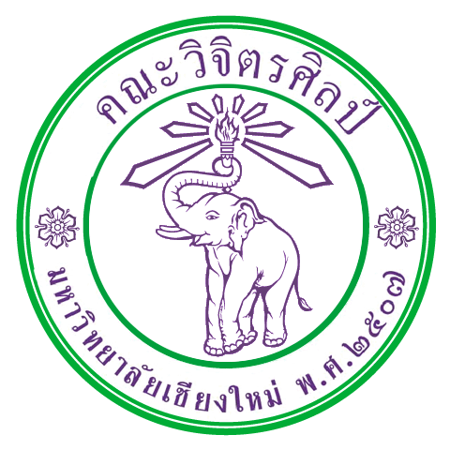

International Relations Office
Faculty of Fine Arts
Chiang Mai University
239 Huay Kaew Road
Chiang Mai 50200 Thailand
Tel/Fax: +66 53 211724
info@finearts.cmu.ac.th
Exchange Student Application Form
Current Study (Project)
Please give information about your current study (Project) and attach the photo.

