CHIANG MAI UNIVERSITY
239 Huay Kaew Rd., Suthep, Muang,
Chiang Mai, Thailand
CERTIFICATE OF HEALTH

(to be complete by the examining physician)

Name: , Sex: Male / Female
Family name First name Middle name

Date of Birth: Age_______________

1. Physical Examination • Laboratory tests

Height: cm. Weight: kg.

Blood Pressure: mmHg mmHg

Urinalysis: Protein ( ) Glucose ( ) Occult Blood ( )

Evesight: Right ( ) Left ( ) Right ( ) Left ( )
Without glasses or contact lenses with glasses or contact lenses

Hearing: Right ( normal / impaired ) Left ( normal / impaired )

2. Please describe the results of physical and X-ray examinations of the applicants’ chest x-rays taken more than 6 months prior to this certification are NOT valid).
Cardiomegaly Lungs
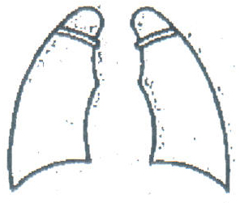
normal normal
impaired impaired

Electrocardiograph Date of X-ray (mandatory)
normal Film No._________
impaired
Describe the condition of applicant’s lungs
3. Under medical treatment at present
Yes (Name of illness: ) (Name of medication:______________________)
No

4. Past history: Please indicate with A (recovered fully), B (receiving follow-up care) or C (under treatment at present).
Name of illness Name of illness
Anemia/blood disease( ) ( ) Tuberculosis ( ) ( )
Heart disease ( )( ) Kidney disease ( ) ( )
Thyroid disease ( ) ( ) Diabetes ( ) ( )
Asthma ( ) ( ) Epilepsy ( ) ( )
Psychosis ( ) ( ) Drug allergy ( ) ( )
Functional disorder in extremities ( ) ( )
Other medical problems or history treatment ( )

5. Particulars or additional comments:
_____________________________________________________________________________________________________

I hereby certify that the above information is correct, and this student does not have any medical problems to study abroad.
Date: Physician’s Name (Print):_______________________________________________

Address:_____________________________________________________________________________________________
Signature:_________________________________________________________________________________________

