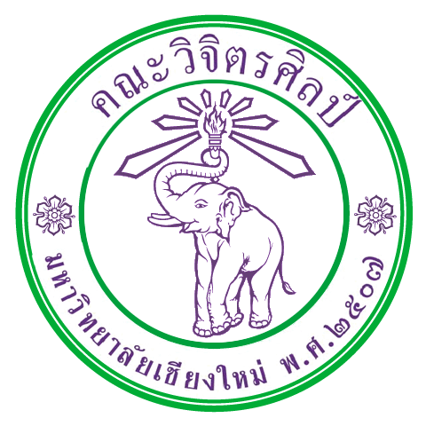

International Relations Office
Faculty of Fine Arts
Chiang Mai University
239 Huay Kaew Road
Chiang Mai 50200 Thailand
Tel/Fax: +66 53 211724
info@finearts.cmu.ac.th
Staff Exchange Program Application Form
Current Project
Please give information about your current project and attach the photo.

