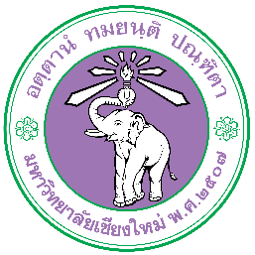
Chiang Mai University Application Form for Outbound Programs
: Otemon Gakuin University, Japan

Coordinator in charge of student exchange (Fill in by Staff)
Faculty/College | Faculty of Fine Arts, Chiang Mai University
Name of Contact Person | Ms. Meviga Han-gla
Position | International Relations Officer
Email | Meviga.h@cmu.ac.th
Phone number | +66 (0) 53944829

Student Information (Fill in by Student)
Tuition Waiver | ☒ Tuition waiver ☐ Fee Paying
Full Name in English
Student ID
Email
Sex (For Arranging Accommodation) | ☐ Male ☐ Female
Date of Birth
Status | ☐ Undergraduate ☐ Master ☐ Ph.D.
Year of Study | ☐ 1 ☐ 2 ☐ 3 ☐ 4
Period of Exchange | ☐ Fall 2026 (1 Semester)  ☐ Fall 2026 & Spring 2027 (2 Semesters)
Japanese Language Proficiency Level | ☐ Beginner  ☐ Elementary  ☐ Intermediate  ☐ JLPT Level (if applicable): N3/N2/N1  ☐ Native
Month/Year of Enrollment at the Home Institution | MM/YYYY
Expected Month/Year of Graduation at the Home Institution (after the exchange program) | MM/YYYY
Preferred Accommodation Type (Select all that apply) | ☐ Dormitory  ☐ Apartment  ☐ Homestay
Health Condition
For your safety and in case of emergency, please list any medical conditions, allergies, mental health concerns, or regular medications we should know for your safety. For more details, please refer to the Factsheet.

I hereby confirm that the above information is correct and has been approved by the affiliated faculty/college.
Signature  (Student’s full name)  Date: | Signature  (Ms.Meviga Han-gla)  Date:

